Outlook Job Manager
Automated Job Email Extraction to Google Sheets
N8N Automation Report
━━━━━━━━━━━━━━━━━━━━━━
Microsoft Outlook • OpenAI GPT-4o-mini • Google Sheets • N8N

Trigger | Microsoft Outlook ,every minute (new email received)
Platform | N8N (Published v1.0)
Integrations | Microsoft Outlook OAuth2, OpenAI GPT-4o-mini, Google Sheets OAuth2
AI Model | GPT-4o-mini (×2 agents) email classification + data extraction
Output | Extracted job details saved to Google Sheets: 'Outlook Mail's Data'
Performance | 5–10 seconds per email | Duplicate prevention via Job Description matching

Project Overview
The Outlook Job Manager is an n8n automation workflow that monitors a Microsoft Outlook inbox every minute, uses AI to identify job vacancy emails, extracts structured job data from each vacancy, and saves the results to a Google Sheet. The workflow eliminates manual scanning of job-related emails, ensuring every relevant vacancy is captured, structured, and stored automatically without any human involvement.
Two GPT-4o-mini AI agents handle the intelligent processing: the first classifies whether an email is a job vacancy or not, and the second extracts the eight key data fields from confirmed vacancies. Non-vacancy emails including internal emails, invoices, newsletters, and replies are filtered out before any AI processing, keeping the system efficient.

1 | Automation Flow : End to End

Automation Flow
1  Outlook Trigger | 2  Get Email Details | 3  Filter Internal | 4  Get Email Folder | 5  AI: Classify Email | 6  Filter Non-Vacancy | 7  AI: Extract Job Data | 8  Save to Google Sheets

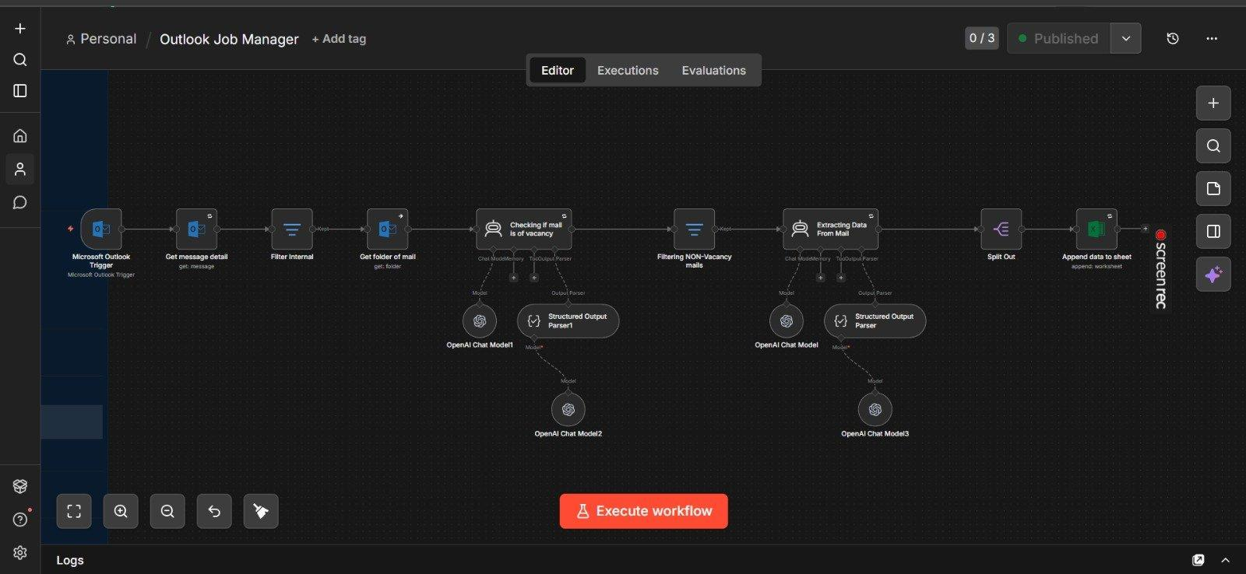
Outlook Job Manager ,Full N8N Workflow (Published)

2 | AI Agents : Roles & Models

Agent | Task | Output
Classification Agent | Reads email subject & body to determine if it is a job vacancy | Returns: VACANCY or NOT_VACANCY
Extraction Agent | Reads vacancy email and extracts all structured job data fields | Returns: structured JSON with 8 job fields

3 | How It Works ,Step by Step

- Step 1 : Microsoft Outlook Trigger: The workflow fires every minute, checking for new emails in the Outlook inbox via Microsoft Outlook OAuth2 authentication.
- Step 2 : Get Message Detail: Full email details are fetched ,subject, body, sender, and metadata ,using the Get Message node.
- Step 3 : Filter Internal: Emails sent from internal addresses (@helixons.nl) are excluded immediately. This prevents internal communications from being processed as job vacancies.
- Step 4 ,Get Folder of Mail: The Outlook folder the email arrived in is retrieved, which is later stored as the Source Folder field in the sheet.
- Step 5 ,AI Classification (Checking if mail is a vacancy): The first GPT-4o-mini agent reads the email subject and body and classifies it as either VACANCY or NOT_VACANCY using a structured output parser to ensure a clean, parseable response.
- Step 6 ,Filter Non-Vacancy Mails: Emails classified as NOT_VACANCY are dropped here. Only confirmed vacancies proceed to the extraction stage.
- Step 7 ,AI Data Extraction (Extracting Data From Mail): The second GPT-4o-mini agent reads the vacancy email and extracts eight structured fields ,Job Title, Client, Location, Job Description, Rate/Salary, Closing Date, Source Folder, and Sender Email. Missing fields return 'NAN'.
- Step 8 : Split Out: Extracted data is split into individual items ready for sheet insertion.
- Step 9 : Append to Google Sheets: Each vacancy is appended as a new row to the 'Outlook Mail's Data' Google Sheet. If a record with the same Job Description already exists, it is updated rather than duplicated.

4 | AI Classification Rules : VACANCY vs NOT_VACANCY

VACANCY : Process | NOT_VACANCY ,Skip
• Job titles, roles, or positions  • Job descriptions or responsibilities  • Salary, rates, or compensation details  • Requests for candidates or CVs | • Invoices or payment receipts  • Meeting invites or calendar events  • Newsletters or marketing emails  • Reply emails ('Thanks', 'Noted', etc.)

5 | Extracted Job Fields : Google Sheets Output

Field | Description
Job Title | The role or position advertised in the email
Client / Project | The company, agency, or project the role is associated with
Location | City, country, or remote status of the job
Job Description | Summary of responsibilities and requirements; also used for duplicate detection
Rate / Salary | Compensation details hourly rate, daily rate, or annual salary
Closing Date | Application deadline extracted from the email
Source Folder | The Outlook folder from which the email was read
Sender Email | The email address of the person or organisation who sent the vacancy

Any field not found in the email is returned as 'NAN' ensuring the sheet row is always complete and no empty cells break downstream processes.

6 | Example : Input Email & Extracted Output

Input Email
- From: recruiter@agency.com
- Subject: Senior Developer Amsterdam
- Body: Hiring Full Stack Developer, €600/day, Closes Feb 15

Output Row Saved to Google Sheets
Job Title | Client | Location | Rate | Closing Date | Sender
Senior Full Stack Developer | Agency | Amsterdam | €600/day | Feb 15, 2026 | recruiter@agency.com

7 | Required Credentials

Credential | Purpose
Microsoft Outlook OAuth2 | Authenticate to read emails and access Outlook folders
OpenAI API Key | Access GPT-4o-mini for email classification and data extraction
Google Sheets OAuth2 | Authenticate to append and update rows in the target spreadsheet

8 | Troubleshooting

Issue | Solution
No emails processing | Check Outlook trigger is active and credentials are valid
All emails marked NOT_VACANCY | Verify email body content is being read correctly in the Get Message node
Too many NAN values | Check email format some senders may use image-only emails without parseable text
Duplicate entries appear | Ensure Job Description field matching is enabled in the Google Sheets append node

9 | Maintenance Schedule

- Monthly: Review data quality in Google Sheets check for unexpected NAN values, missed vacancies, or incorrectly classified emails.
- Quarterly: Review AI classification accuracy adjust the system prompt if new email formats are producing incorrect VACANCY / NOT_VACANCY results.
- As Needed: Update extraction prompts when new vacancy email formats are detected that produce incomplete or malformed field extraction.

System Architecture Summary

INPUT | N8N AUTOMATION | OUTPUT
• Outlook Inbox Emails  • Every 1 Minute  • All Senders / All Folders | • Filter Internal (@helixons.nl)  • AI: Classify as VACANCY  • Filter Non-Vacancy Emails  • AI: Extract 8 Job Fields  • Split Out & Append to Sheet | • Structured Job Record in Sheet  • 8 Fields Per Vacancy  • Duplicates Prevented  • NAN for Missing Data

Technical Details
- Workflow ID: 0169d097b99abd86140ed74424abfacd63cb6eaa65c1383d6f7a415ba1a0a554
- Version: 1.0 | Status: Published
- Processing Speed: 5–10 seconds per email
- Duplicate Prevention: Job Description field matching existing records are updated, not duplicated
- Missing Data Handling: Returns 'NAN' for any field not found in the email

━━━━━━━━━━━━━━━━━━━━━━━━━━━━━━━━━━━
End of Document , Outlook Job Manager | N8N Automation

